**GROUP – A**

**Assignment No: 2**

====================================================================

Title:-

Implement Huffman encoding using a greedy method

=====================================================================Objective:-

-To learn about Huffman encoding

-To understand greedy method

=====================================================================

Theory:-

* Huffman coding is a lossless data compression algorithm. The idea is to assign variable-length codes to input characters; lengths of the assigned codes are based on the frequencies of corresponding characters. The most frequent character gets the smallest code and the least frequent character gets the largest code.
* The variable-length codes assigned to input characters are Prefix Codes, means the codes (bit sequences) are assigned in such a way that the code assigned to one character is not the prefix of code assigned to any other character. This is how Huffman Coding makes sure that there is no ambiguity when decoding the generated bitstream.
* For example of prefix codes with a counter example, there be four characters a, b, c and d, and their corresponding variable length codes be 00, 01, 0 and 1. This coding leads to ambiguity because code assigned to c is the prefix of codes assigned to a and b. If the compressed bit stream is 0001, the de-compressed output may be “cccd” or “ccb” or “acd” or “ab”.
* There are mainly two major parts in Huffman Coding

1. Build a Huffman Tree from input characters.
2. Traverse the Huffman Tree and assign codes to characters.

* How Huffman Coding works?

Input is an array of unique characters along with their frequency of occurrences and output is Huffman Tree.

* Create a leaf node for each unique character and build a min heap of all leaf nodes (Min Heap is used as a priority queue. The value of frequency field is used to compare two nodes in min heap. Initially, the least frequent character is at root)
* Extract two nodes with the minimum frequency from the min heap.
* Create a new internal node with a frequency equal to the sum of the two nodes frequencies. Make the first extracted node as its left child and the other extracted node as its right child. Add this node to the min heap.
* Repeat steps 2 and 3 until the heap contains only one node. The remaining node is the root node and the tree is complete.
* Practice problem based on job sequencing with deadline
* Problem : - Jobs are given with their deadline and associated profits,

|  |  |
| --- | --- |
| **Character** | **Frequency** |
| a | 5 |
| b | 9 |
| c | 12 |
| d | 13 |
| e | 16 |
| f | 45 |

* Step 1: Build a min heap that contains 6 nodes where each node represents root of a tree with single node.
* Step 2 Extract two minimum frequency nodes from min heap. Add a new internal node with frequency 5 + 9 = 14.

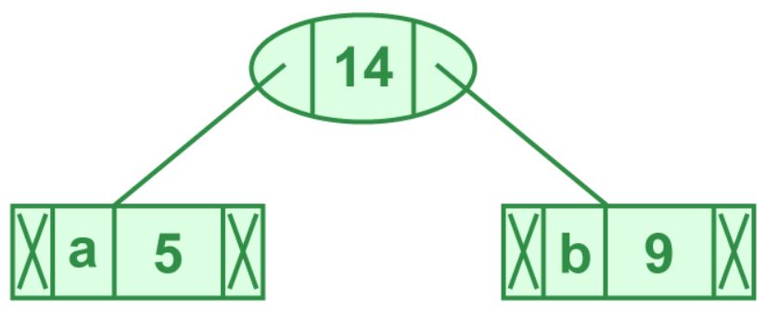

Now min heap contains 5 nodes where 4 nodes are roots of trees with single element each, and one heap node is root of tree with 3 elements.

|  |  |
| --- | --- |
| **Character** | **Frequency** |
| c | 12 |
| d | 13 |
| internal node | 14 |
| e | 16 |
| f | 45 |

* Step 3: Extract two minimum frequency nodes from heap. Add a new internal node with frequency 12 + 13 = 25

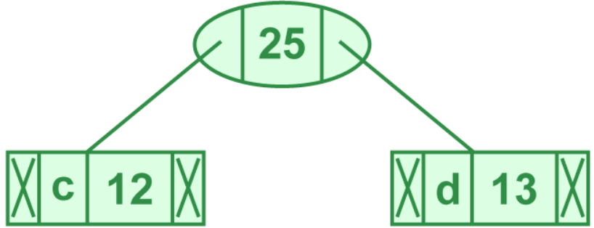

Now min heap contains 4 nodes where 2 nodes are roots of trees with single element each, and two heap nodes are root of tree with more than one nodes.

|  |  |
| --- | --- |
| **Character** | **Frequency** |
| internal node | 14 |
| e | 16 |
| internal node | 25 |
| f | 45 |

* Step 4: Extract two minimum frequency nodes. Add a new internal node with frequency 14 + 16 = 30

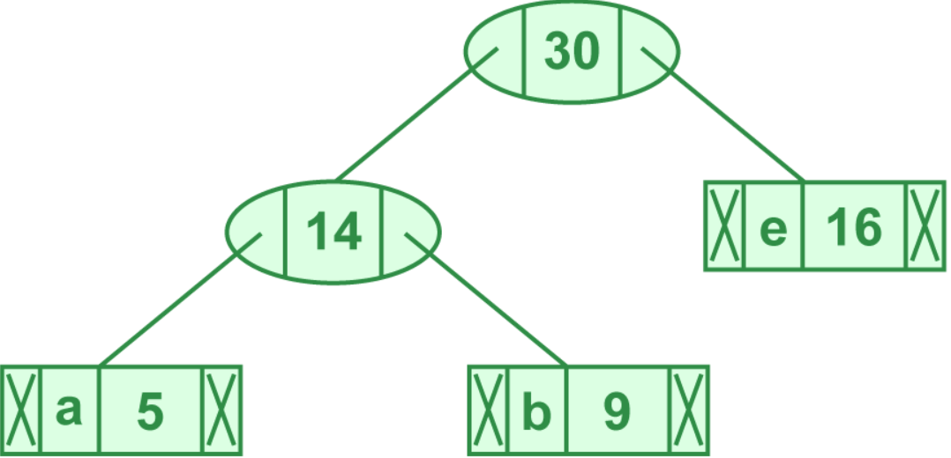

Now min heap contains 3 nodes.

|  |  |
| --- | --- |
| **Character** | **Frequency** |
| internal node | 25 |
| internal node | 25 |
| f | 45 |

* Step 5: Extract two minimum frequency nodes. Add a new internal node with frequency 25 + 30 = 55

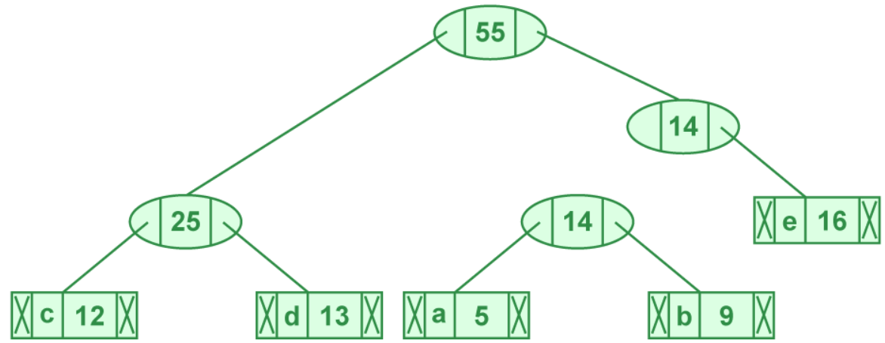

Now min heap contains 2 nodes.

|  |  |
| --- | --- |
| **Character** | **Frequency** |
| f | 45 |
| internal node | 55 |

* Step 6: Extract two minimum frequency nodes. Add a new internal node with frequency 45 + 55 = 100

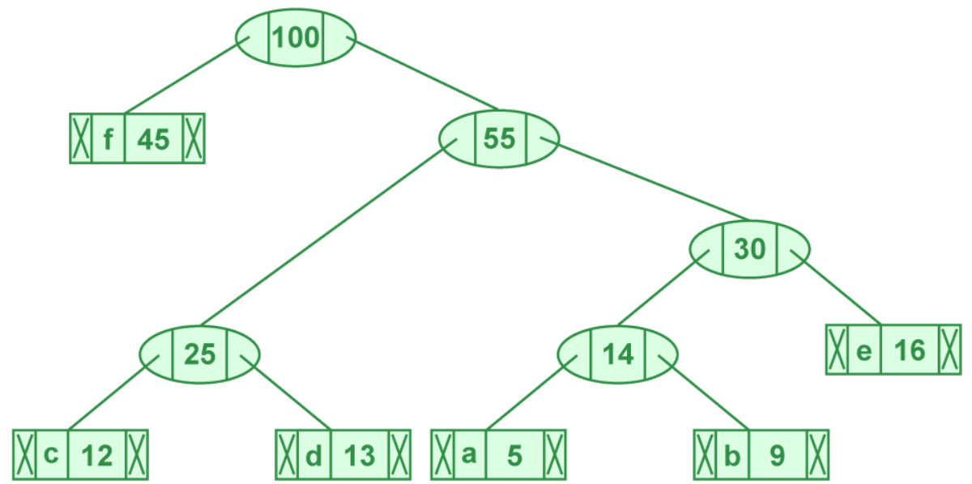

Now min heap contains only one node,

|  |  |
| --- | --- |
| **Character** | **Frequency** |
| internal node | 100 |

Since the heap contains only one node, the last step is to print code from human tree:

* Step 7: Step to print codes from Huffman tree:

Traverse the tree formed starting from the root. Maintain an auxiliary array. While moving to the left child, write 0 to the array. While moving to the right child, write 1 to the array. Print the array when a leaf node is encountered.

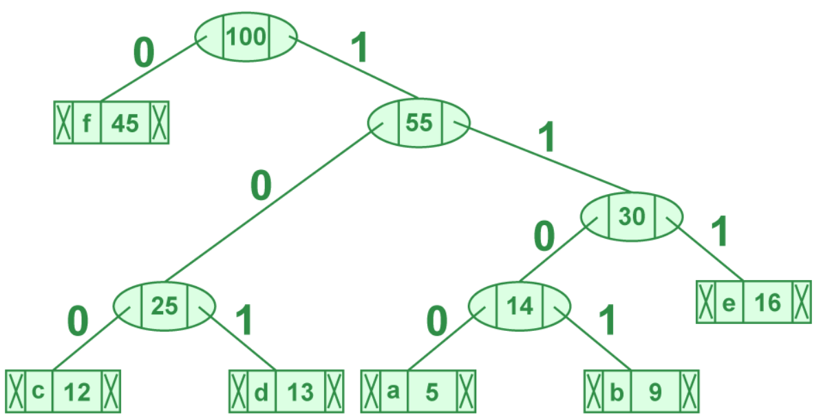

The Huffman code is as follows:

|  |  |
| --- | --- |
| **Character** | **Code Word** |
| f | 0 |
| c | 100 |
| d | 101 |
| a | 1100 |
| b | 1101 |
| e | 111 |

Algorithm: Job-Sequencing-With-Deadline (D, J, n, k)

D(0) := J(0) := 0

k := 1

J(1) := 1 // means first job is selected

for i = 2 … n do

r := k

while D(J(r)) > D(i) and D(J(r)) ≠ r do

r := r – 1

if D(J(r)) ≤ D(i) and D(i) > r then

for l = k … r + 1 by -1 do

J(l + 1) := J(l)

J(r + 1) := i

k := k + 1

* Time Complexity and Space Complexity of Job sequencing with deadline

O(nlogn) where n is the number of unique characters. If there are n nodes, extractMin() is called 2*(n – 1) times. extractMin() takes O(logn) time as it calls minHeapify(). So, overall complexity is O(nlogn).

=====================================================================

Conclusion:-

Thus we have studied to how Huffman coding using greedy method works. The use of greedy method is solving a problem by selecting the best option available at the moment.

=====================================================================